1.11 Supplementary Materials
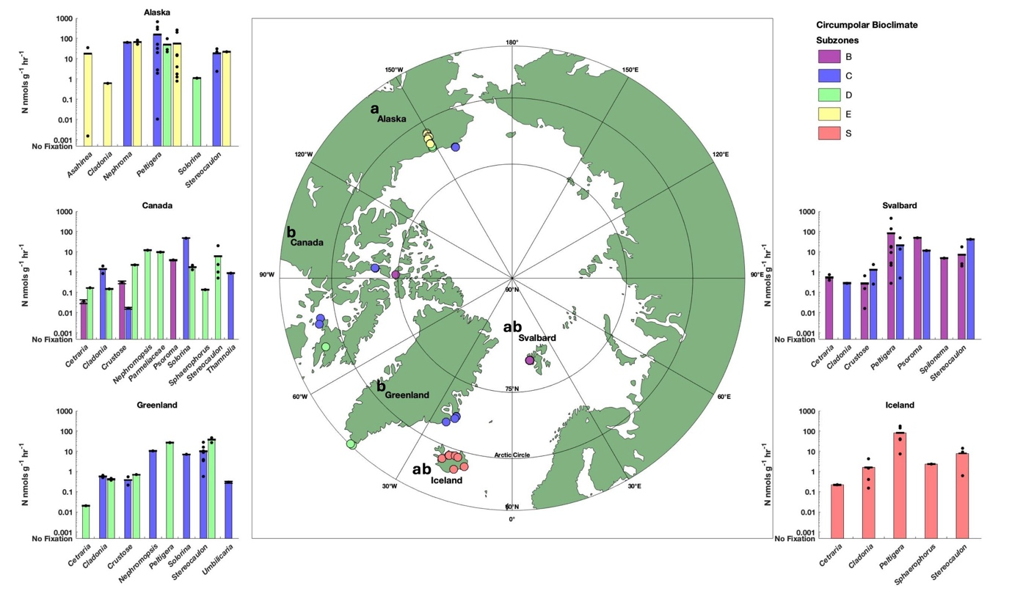
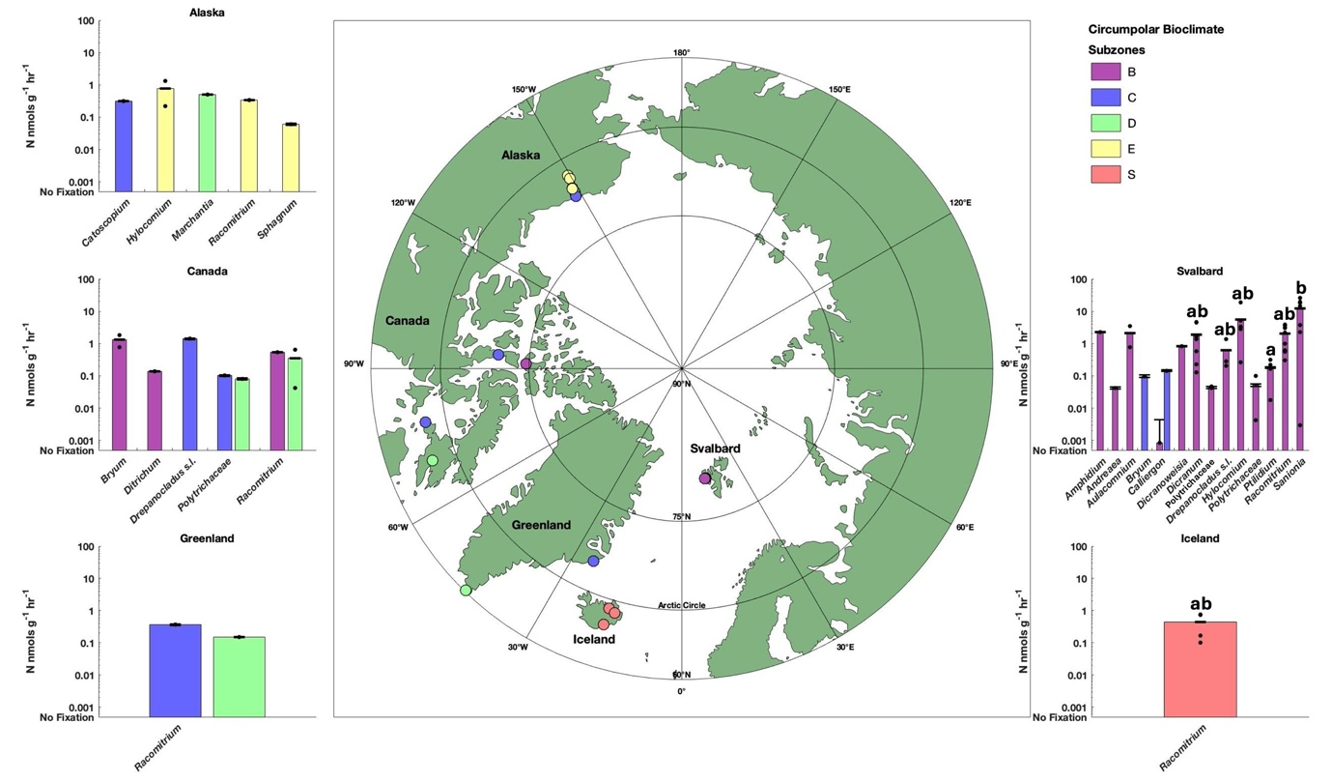
Figure S1: Collection map with BNF rates of fixing lichen (top) and bryophyte (bottom) genera by subzone and collection location. Letters (a, b) signify significant differences (p-value < 0.05) in BNF rates among collection location or specific genus-subzone samples locations as the result of a Kruskal-Wallis test followed by a Dunn’s post-hoc test. Samples without fixation were assigned an arbitrarily small positive value (smaller than any fixing value) in order to plot on the logarithmic y-axis.

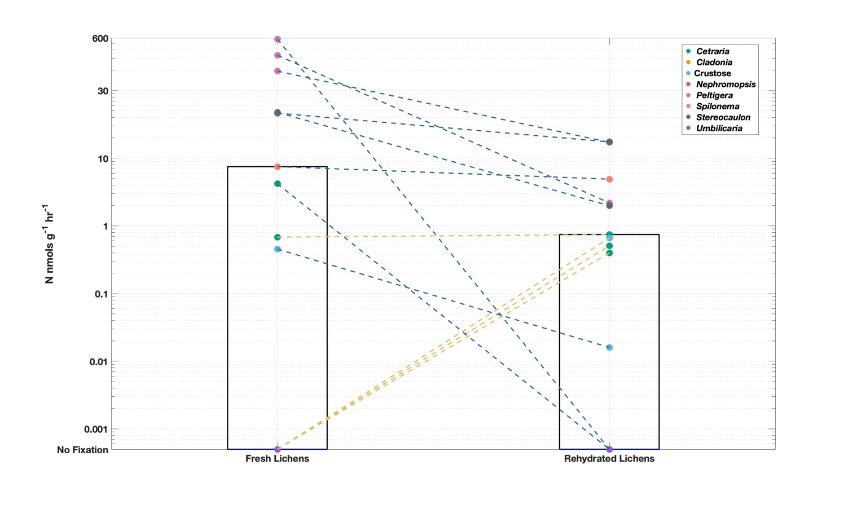
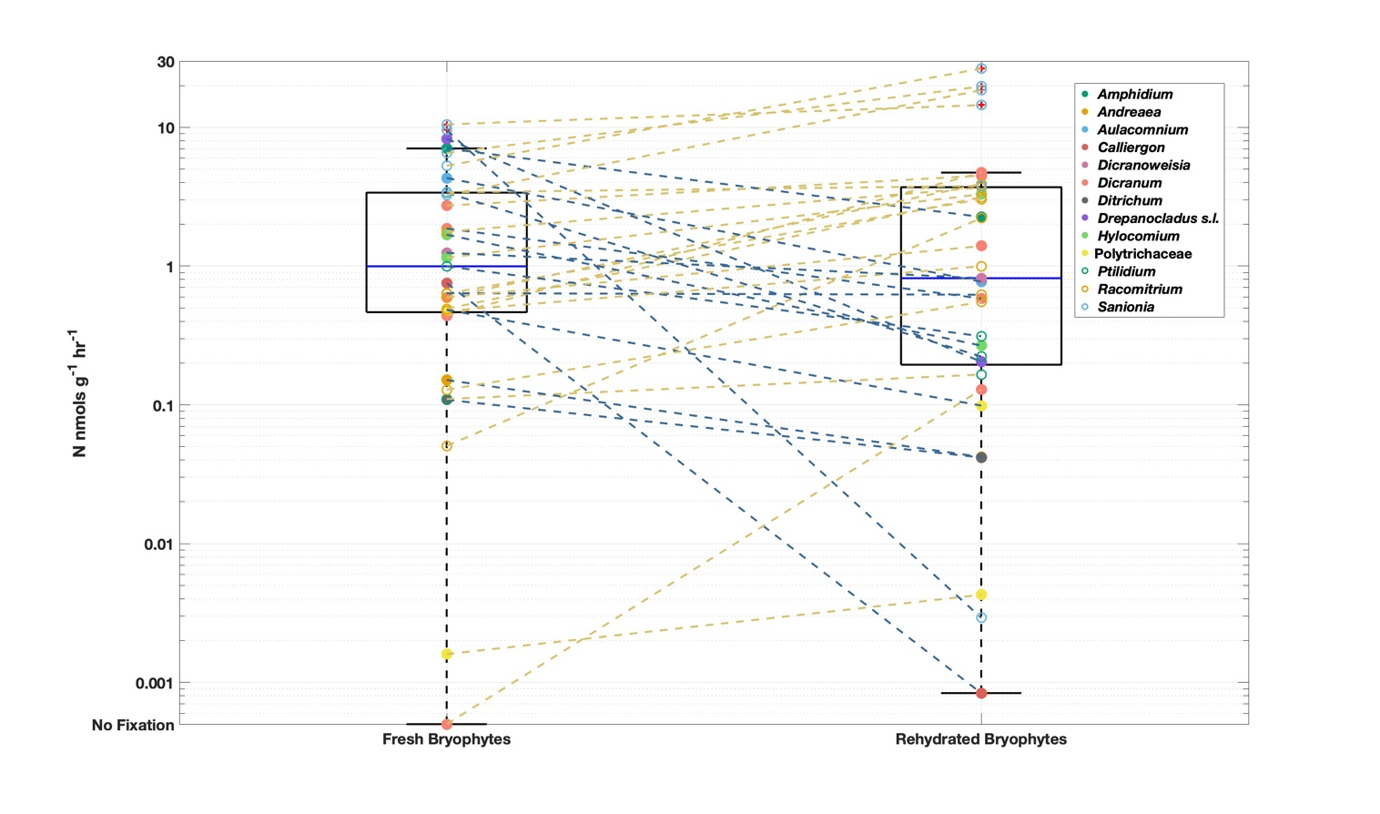
Figure S2: Comparison of fresh and rehydrated BNF rates for lichens (top) and bryophytes (bottom) sampled in Svalbard in 2023. Solid blue lines represent median values. Dashed blue lines track samples with higher fresh than rehydrated rates, and dashed gold lines track samples with higher rehydrated than fresh rates. Samples without fixation were assigned an arbitrarily small positive value (smaller than any fixing value) in order to plot on the logarithmic y-axis.

Location | Site | Subzone | Latitude | Longitude | Lichen Samples | Bryophyte Samples | Collection Date
Alaska | 1A | E | 68.0302 | -149.6798 | 4 | 1 | Aug 03, 2022
 | 2A | E | 68.1576 | -149.44 | 10 | 3 | Aug 03, 2022
 | 3A | E | 68.455 | -149.3778 | 1 | 1 | Aug 03, 2022
 | 4A | E | 68.4709 | -149.5289 | 5 | 8 | Aug 04, 2022
 | 5A | E | 68.6447 | -149.5787 | 4 | 3 | Aug 04, 2022
 | 6A | E | 68.7613 | -148.8867 | 3 | 2 | Aug 04, 2022
 | 7A | E | 69.0705 | -148.8219 | 0 | 2 | Aug 04, 2022
 | 8A | E | 69.4124 | -148.7236 | 3 | 2 | Aug 05, 2022
 | 9A | E | 69.4479 | -148.6261 | 1 | 3 | Aug 05, 2022
 | 10A | D | 69.6747 | -148.709 | 1 | 4 | Aug 02, 2022
 | 11A | D | 69.8529 | -148.7666 | 5 | 7 | Aug 02, 2022
 | 12A | D | 70.0313 | -148.6357 | 2 | 3 | Aug 02, 2022
 | 13A | C | 70.2366 | -148.38 | 0 | 1 | Aug 02, 2022
 | 14A | C | 71.2466 | -156.6359 | 8 | 8 | Jul 30, 2022
 | 15A | C | 71.2511 | -156.4766 | 4 | 0 | Jul 30, 2022
 | 16A | C | 71.2834 | -156.6563 | 3 | 4 | Jul 29, 2022
 | 17A | C | 71.2969 | -156.6829 | 5 | 0 | Jul 30, 2022
Canada | 1C | D | 64.2219 | -69.804 | 24 | 11 | Jul 15, 2023
 | 2C | C | 64.2451 | -76.5647 | 10 | 4 | Sep 16, 2022
 | 3C | C | 64.5714 | -78.1754 | 8 | 9 | Sep 15, 2022
 | 4C | C | 72.0322 | -94.1861 | 7 | 12 | Sep 19, 2022
 | 5C | B | 74.7288 | -91.7794 | 5 | 4 | Sep 20, 2022
Greenland | 1G | D | 60.1545 | -44.287 | 15 | 10 | Sep 10, 2022
 | 2G | D | 60.1587 | -43.6384 | 7 | 5 | Sep 09, 2022
 | 3G | C | 69.3198 | -24.604 | 9 | 1 | Jun 05, 2023
 | 4G | C | 69.98 | -22.5175 | 3 | 2 | Jun 04, 2023
 | 5G | C | 70.1292 | -22.2428 | 8 | 4 | May 30, 2023
 | 6G | C | 70.47 | -21.9429 | 8 | 3 | May 29, 2023
 | 7G | C | 70.4874 | -21.9494 | 12 | 2 | May 28, 2023
Iceland | 1I | S | 64.022 | -16.9474 | 3 | 3 | Sep 04, 2022
 | 2I | S | 64.0302 | -22.0916 | 0 | 3 | Sep 05, 2022
 | 3I | S | 64.7018 | -14.2882 | 8 | 4 | Sep 04, 2022
 | 4I | S | 64.8562 | -21.2109 | 3 | 3 | Sep 02, 2022
 | 5I | S | 65.126 | -14.3329 | 1 | 3 | Sep 04, 2022
 | 6I | S | 65.3753 | -15.4248 | 0 | 3 | Sep 03, 2022
 | 7I | S | 65.4634 | -18.8689 | 2 | 1 | Sep 03, 2022
 | 8I | S | 65.5131 | -19.6471 | 4 | 2 | Sep 03, 2022
 | 9I | S | 65.6536 | -16.935 | 4 | 3 | Sep 03, 2022
 | 10I | S | 65.6715 | -18.0428 | 0 | 1 | Sep 03, 2022
 | 11I | S | 65.7143 | -17.7405 | 6 | 0 | Sep 03, 2022
Svalbard | 1S | C | 78.9152 | 11.9149 | 1 | 4 | Jul 05, 2022
 | 2S | C | 78.9158 | 11.9467 | 1 | 2 | Jul 06, 2022
 | 3S | C | 78.9189 | 11.958 | 1 | 4 | Jul 06, 2022
 | 4S | B | 78.921 | 11.8305 | 13 | 26 | Aug 30–Sep 01, 2023
 | 5S | B | 78.9222 | 11.8641 | 6 | 13 | Aug 29–Sep 05, 2023
 | 6S | B | 78.9228 | 11.8694 | 9 | 8 | Sep 02–Sep 05, 2023
 | 7S | B | 78.9574 | 11.6834 | 6 | 4 | Jul 10, 2022
 | 8S | C | 78.984 | 12.273 | 3 | 8 | Jul 08, 2022
 | 9S | C | 78.9855 | 12.267 | 4 | 7 | Jul 08, 2022
Table S1: Metadata of collection sites used in this study. Latitude and longitude values represent the geographic center point of all samples collected at each site. Individual sample details are available on Zenodo.

