Supplementary Figures

Fig. S1. (a) Schematic workflow for environmental Dicranum scoparium sampling and subsequent read mapping; (b) workflow for Fungal Nutrient Transporter Database (FNTD) construction; (c) workflow for assembling the Fungal CAZy Database (FCD); (d) workflow for Axenic Dicranum scoparium Transcriptome Database (ADTD) construction.
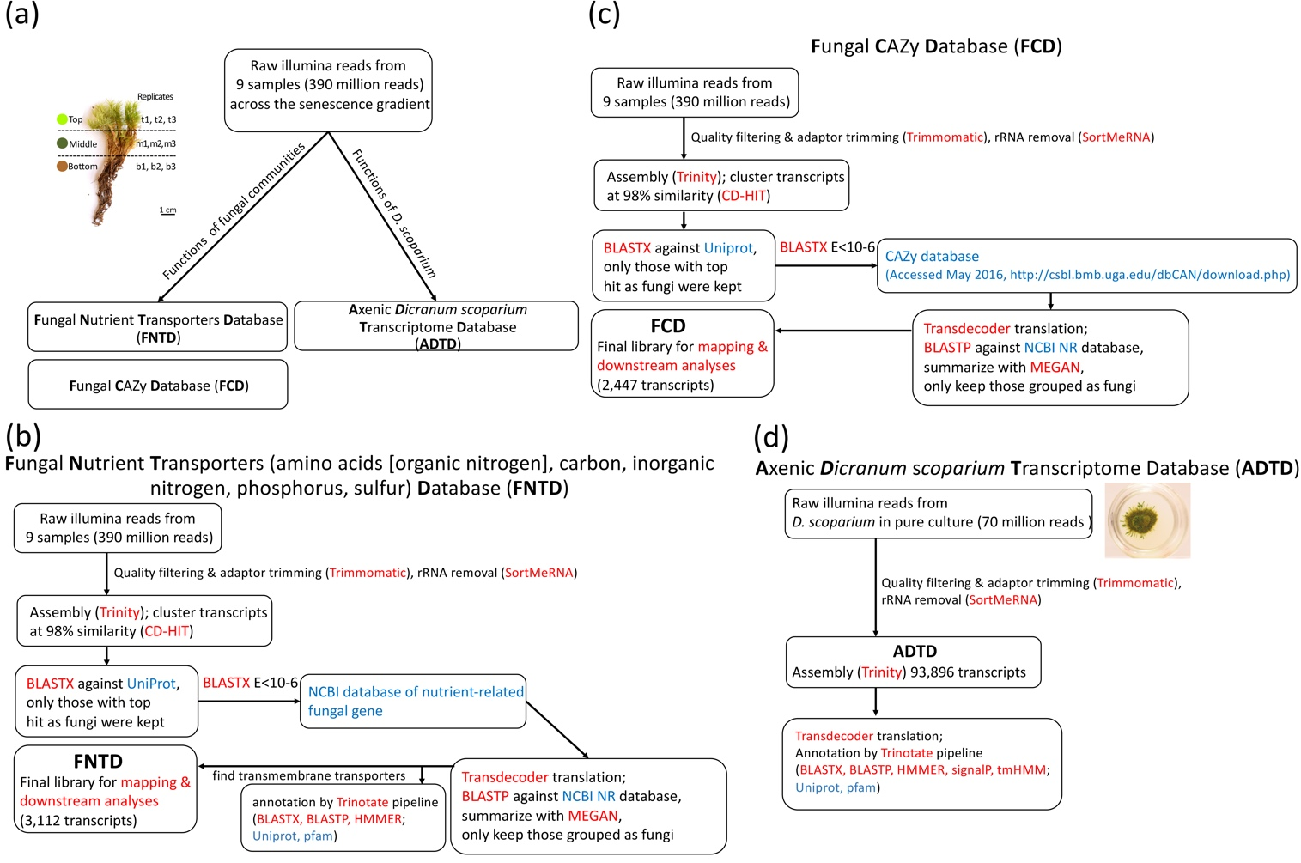

Fig. S2. Percentage of reads mapped to assembled transcripts assigned to 10 taxonomic groups.
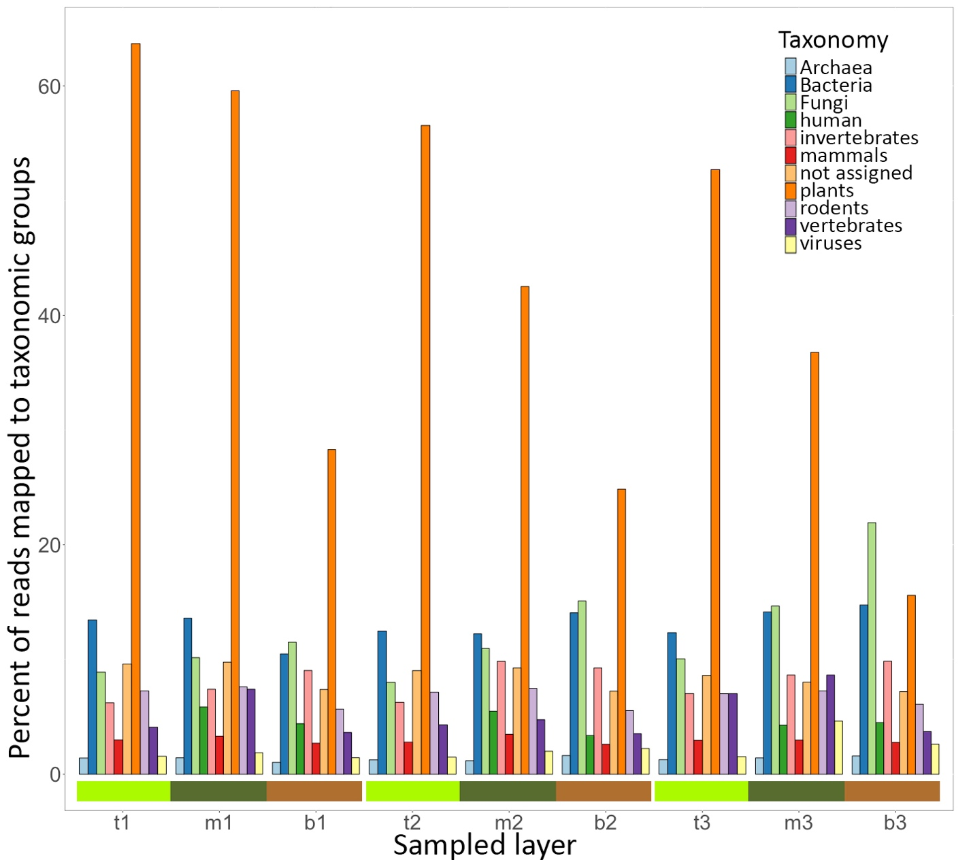

Fig. S3. Principal coordinate analyses of (a) Fungal Nutrient Transporters (FNTD), (b) fungal CAZy (FCD), and (c) axenic Dicranum scoparium (ADTD) expression levels across replicates and senescence layers of D. scoparium.
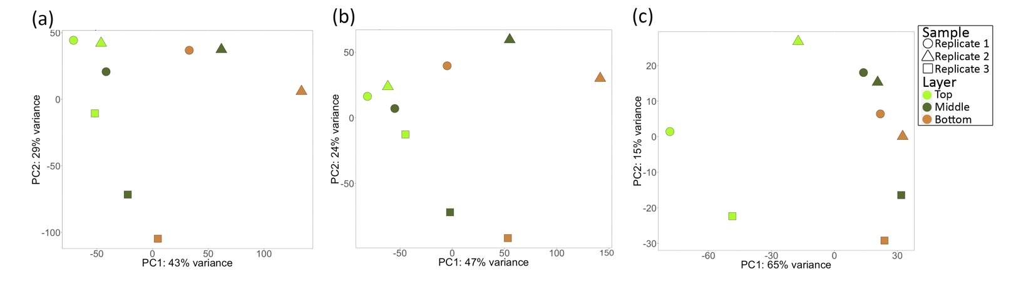

Fig. S4. Taxonomic distribution of 3,112 fungal nutrient transporter genes (amino acids [organic nitrogen], carbon, inorganic nitrogen, phosphorus and sulfur) found in fungal communities associated with Dicranum scoparium.
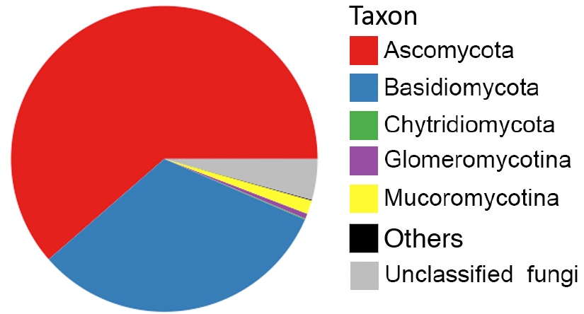

Fig. S5. Ammonium transporter/methylammonium permease/Rhesus factor (AMT/MEP/Rh) gene family ML tree. Nomenclature of the gene clades follows Mcdonald et al. (2012). Red asterisks show phylogenetic placement of ammonium transporters we detected from fungi associated with Dicranum scoparium.
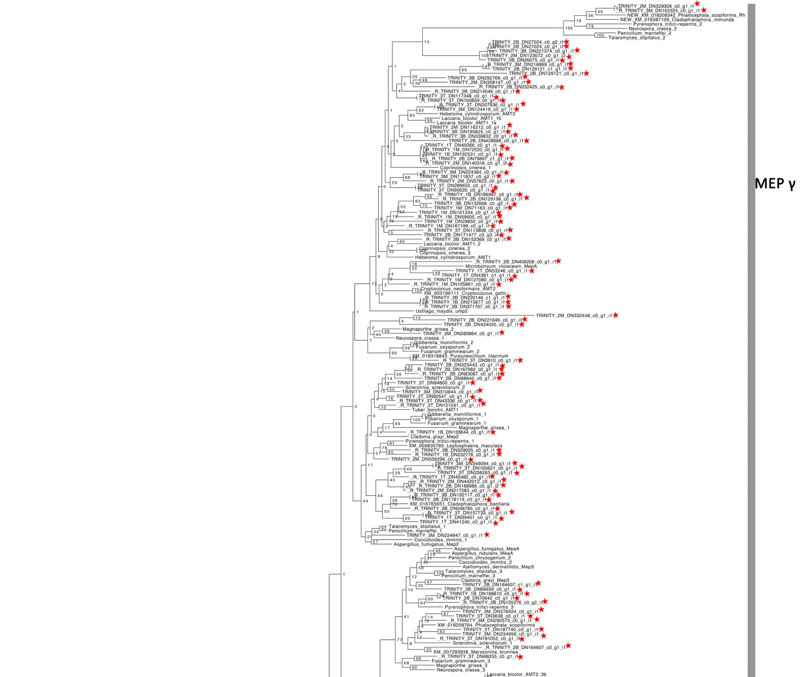
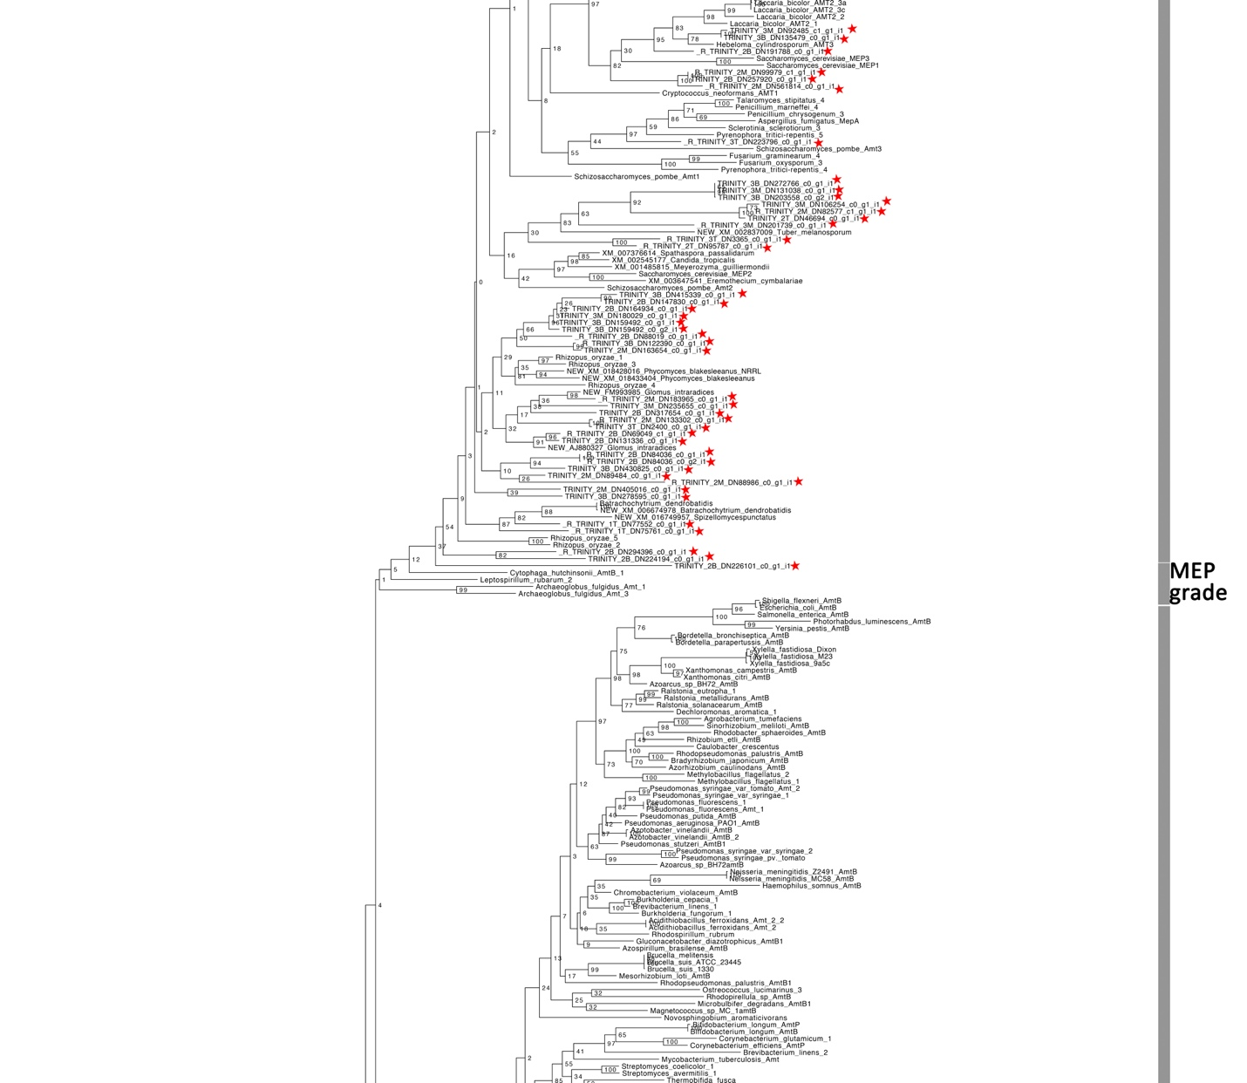

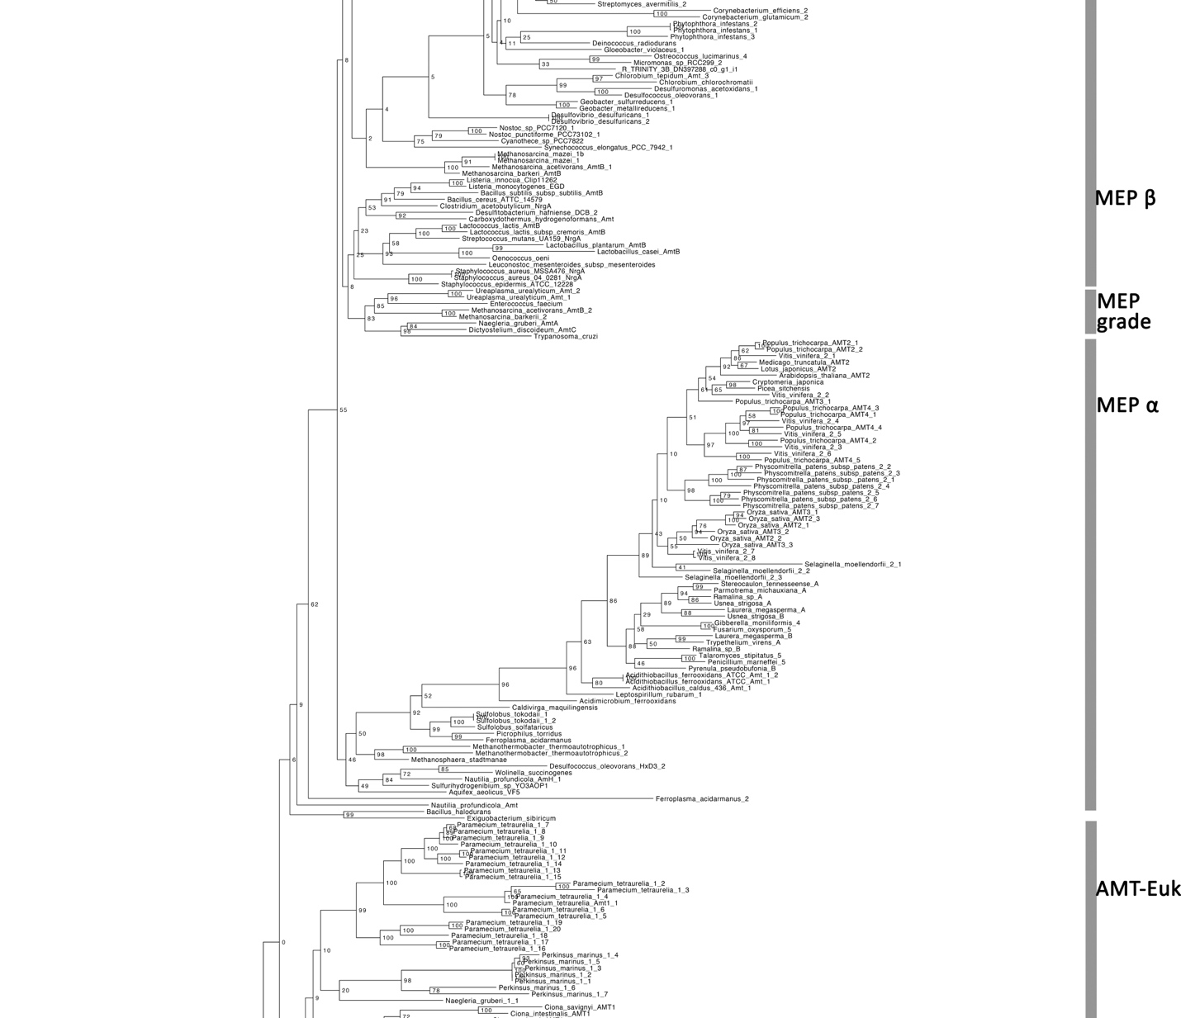

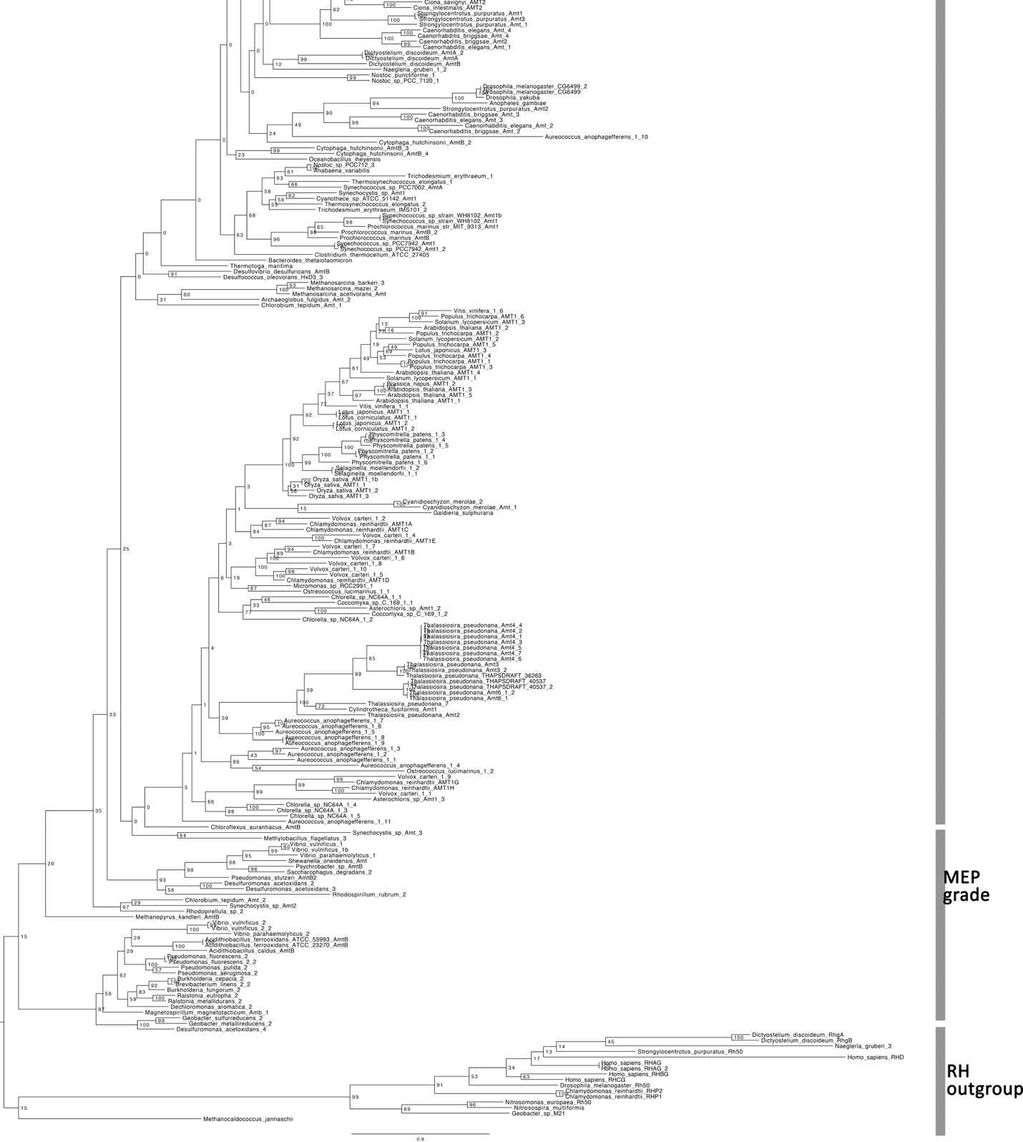

Fig. S6. Expression levels of commonly expressed LRR/defense/symbiosis related genes of D. scoparium in the top and bottom layers.
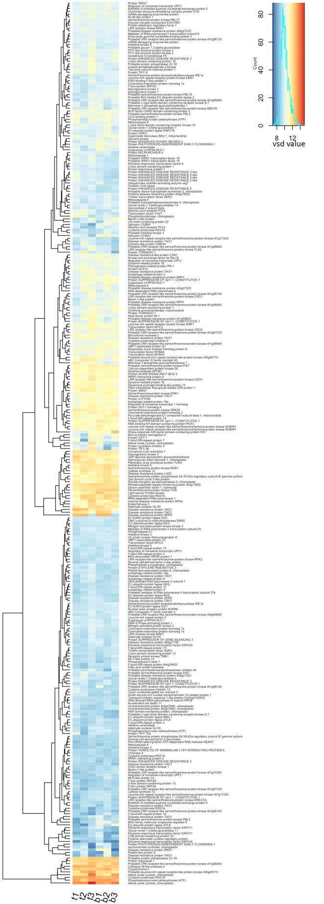
Fig. S7. Differentially expressed genes of D. scoparium associated with enriched catabolic processes (GO term enriched, P < 0.05).
